C229 Single Camera Production – Week 8

Week 8 Agenda:
- Readings/watchlist
- Review camera framing, angle of view & f-stop
- Intro to Continuity
- Short in-class Canvas attendance exercise
- Intro to Canon 80D

Readings/Watchlist:
- Canon 80D manual (Familiarize yourself with it, get to know where things are like setting shooting modes, setting white balance, etc.) You might want to download it to your phone.
- Review: Lens Basics (Sony) & Camera Shot Types (B&H Explora)
- Continuity Editing in Film (Studio Binder)
  - The 180-degree Rule
  - What’s the 30-degree rule?
  - Match Cuts
  - Eye Trace
- Cuts & Transitions 101 (Rocket Jump Film School)

Framing – Be sure you know your basic shot types. Review the B&H Explora article on shot types and the Cheat Sheet below from Studio Binder.

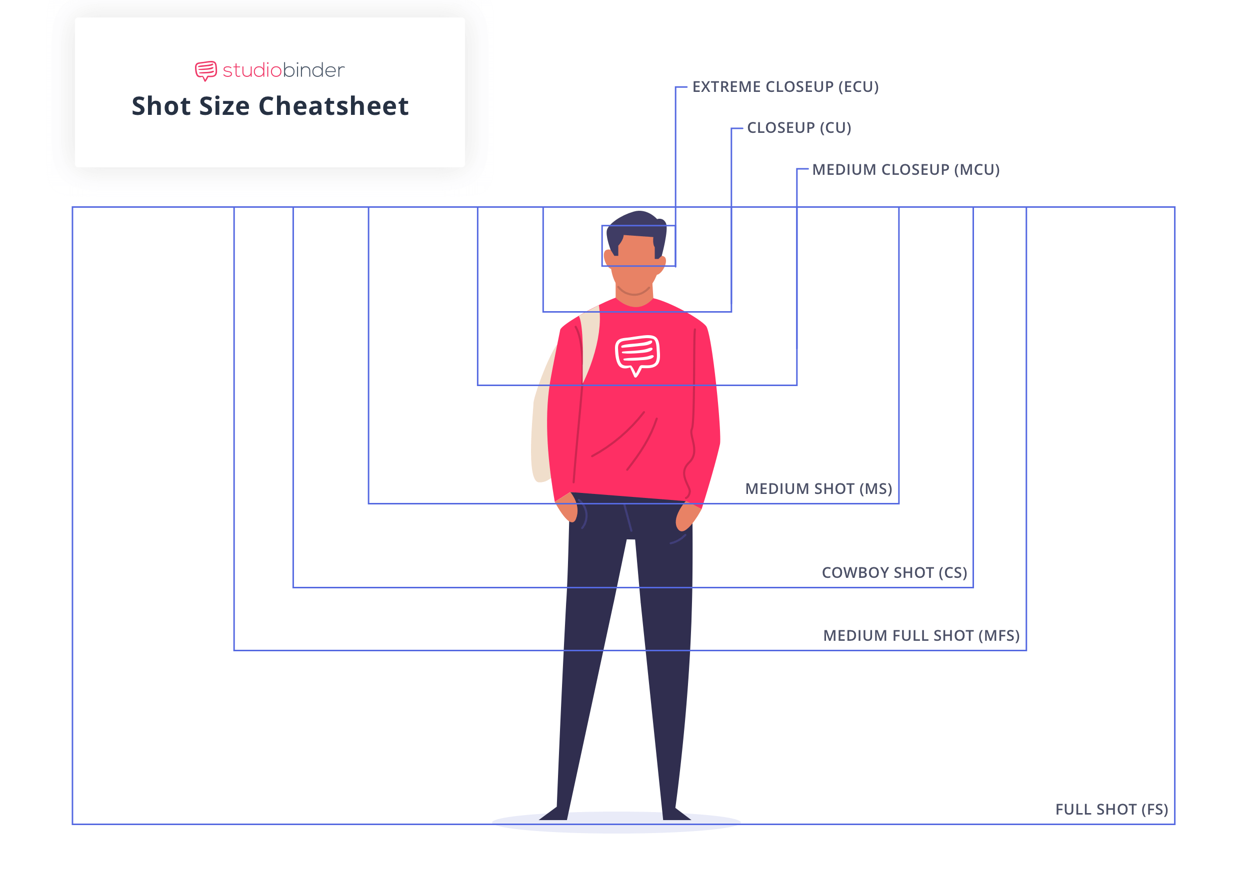
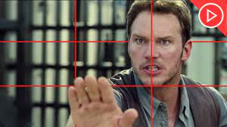 | 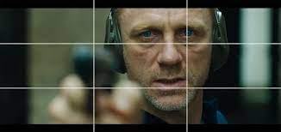
When framing medium close-ups, close-ups, and extreme close-ups, it’s common practice to keep eyes positioned on the top line of the rule of thirds. See how the eyes are positioned on the top line and that lead room is given in both images? Lead room is extra space in the frame provided in the direction of a gaze or movement.

When framing and setting up shots, keep in mind the camera lens’s focal length and angle of view. A telephoto lens has a narrow angle of view (E.g., 10°) while a wide-angle lens has (as it’s named), a wider angle of view (E.g., 180° on a fisheye lens). It’s possible to get a close-up with either lens below- but the angle of view and placement of the camera would be drastically different.
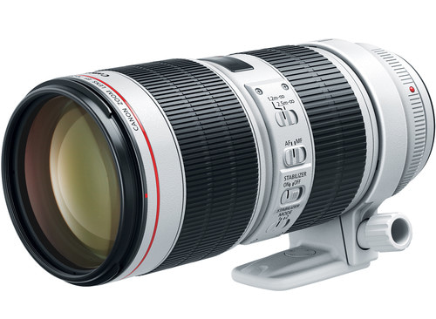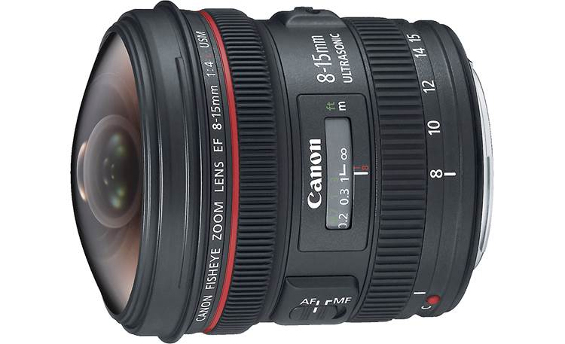

Canon 70-200 mm telephoto Canon 8-15 mm wide-angle lens

Variable focal length lenses vs Prime Lenses - Both lenses above have variable focal lengths. Lenses with fixed focal lengths are called prime lenses, such as the 50mm lens below on the right. The lens below on the left has a variable focal length, from 24-105mm. (A good all-around lens.)

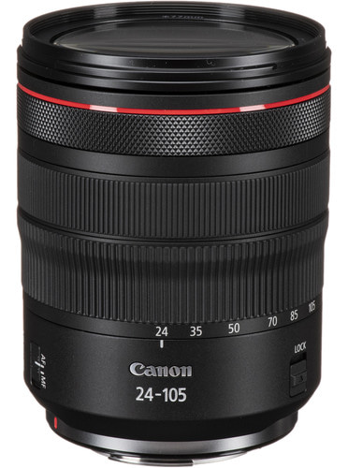  Canon EF 24-105 mm f/4 zoom lens | 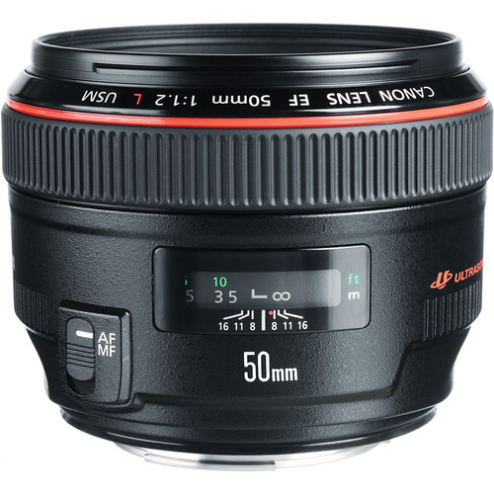 Canon EF 50mm f/1.2 prime lens
Image Sensors and Lens Mounts (EF-S, EF, R, PL, etc.) Lens mounts are precisely engineered to connect a lens’s electronics and optics to a specific type of camera body. (You’d attach an EF lens to a camera with an EF mount.) Lens mounts are designed to match the size of the camera’s image sensor. In the Media School we have Canon cameras with different sizes of image sensors (APS-C, Super 35, and 35mm). These fortunately all take EF lenses. Wikipedia has a good comparison of sensors.

Sensor Type | Size (approx.) | Cameras | Compatible lenses
APS-C | 22.5 x 15 mm | Canon Rebel, 80D | EF-S, EF
Super 35 | 24.6/26.2 x 13.8 mm | C100, C300 | EF
35mm / Full frame | 36 x 24 mm | Canon 1D, 5D, 6D | EF

It is possible to attach a different type of lenses to some cameras with an appropriate lens adaptor. For example, I use an EF to R adaptor, which works flawlessly. There are many other types of lens mounts (Canon R, Nikon F, Sony A & E, Arri PL, etc.), which you may encounter.

REVIEW: The Relationship of Aperture and Depth of Field. Larger apertures (E.g., f-2) have a shallower depth of field than smaller apertures (E.g., f-22).
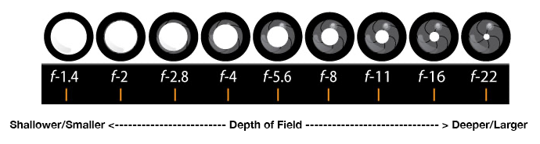
Lens Speed – Lenses can be categorized as slow or fast, which can be confusing. This pertains to the maximum size of the aperture. Slow lenses may only open to f-4 or f-5.6. A fast lens may open to f.1.4. Photographers must use a slower shutter speed with a slower lens but can use a faster shutter speed with a fast lens. With their larger apertures, fast lenses make it easier to get shots with a shallow depth of field. Fast lenses are also essential for photographers who must capture crisp shots of action (racing, sports, dancers, animals in motion, etc.). Fast lenses are more expensive than slower lenses. Check out the price difference of these two telephoto lenses:

- Tokina EF SZX 400mm f/9 ($270 at B&H)
- Canon EF 400mm f/2.8 ($12,000 at B&H)

Continuity - It’s important to understand continuity, its variations, and the many ways it’s used in film production. The underlying concept in continuity is this: Within a scene, we expect people and props to remain faithful to their spatial positions, motion, and for time to move forward. We do not want to take viewers out of the moment by introducing distractions, unintentional jump cuts and continuity errors. Here are some ways to look at continuity:

- Spatial Continuity - the 180-degree axis has been crossed or eyelines don’t match.
- Time Continuity - if a clock, candle, or position of the sun appears in more than one shot, the time must be consistent within the scene.
- Physical Continuity - props and clothing change from shot to shot. If your talent has a jacket or sunglasses on in one shot, they need to be on in the next shot.
- Technical Continuity - shots don’t match in texture, image quality or sound.
- Story Continuity – A story point or character action doesn’t make sense

Spatial Continuity - This can be established by maintaining a 180-degree line, matching eye lines, and following the 30-degree rule.
- 180-degree line – Keep the camera(s) on one side of the line- unless you have an intentional way to cross it. (Introducing a neutral shot, a cutaway, an insert shot, a new character or vector, or by shooting down the line, etc.). A cutaway shot is a shot of something new, outside the action of a scene. Insert shots are often captured from the point of view of the character and can be a close-up detail of something inside the scene they are looking at.
- Match eye lines – This takes planning and thoughtful camera placement to make sure character’s eye lines match.
- 30-degree rule – Change the shot by at least 30 degrees. It’s also important to vary the framing for adjacent shots of the same subject to avoid unintentional jump cuts. Jump cuts are back-to-back similar shots of the same subject (E.g., going from a MCU of a character to another MCU of the same character).

Time and Physical Continuity - Pay attention to attire, hair, clocks, candles, time, and anything else that changes over time. Even the amount of liquid in a glass someone is drinking needs to be monitored. On set, the Script Supervisor is usually tasked with tracking props and continuity issues.

Technical Continuity – Using two cameras that don’t match, varying lighting conditions in the same scene, and mismatched audio recordings are common problems.

Attendance Question: What is the two-letter lens mount that works with both our Canon 80D and C100/C300 cameras?

Intro to the Canon 80D (Manual PDF)

The Canon 80D is a 24-megapixel DSLR with an APS-C sensor and EF/EF-S lens mount. It requires an LP-E6N battery and can record 1920x1080 movies up to 60 fps.
- Unlike the Canon xf605, which has a fixed lens, the 80D can use interchangeable lenses.
- Unlike the Canon xf605 (and like most DSLRs) there is no direct way to capture audio from a microphone via an XLR cable. While you can attach an external mic with the right connectors (mini-phone plug), it is best to record audio via a separate device (E.g., a Sound Device MixPre), which has phantom power to work with professional microphones).

Vocabulary:
- Angle of view
- Aperture
- Continuity (How to maintain in production and editing)
- Cutaway Shot
- Depth of field
- DSLR Camera (Digital Single Lens Reflex Camera)
- EF lens mount
- F-stop
- Focal length
- Jump Cut
- Insert shot
- Lens speed
- Prime lens - A lens with a fixed focal length.
- Zoom lens - A lens that has a variable focal length

