C229 Lecture Week 4 - Loving the Light - Lighting 101

Agenda:
- Lighting
- This week’s production exercise

Reading/Watchlist:
Arri has an excellent lighting handbook they offer free on their website.
https://www.arri.com/en/learn-help/lighting/lighting-handbook

To see how different looks are achieved through lighting, scroll down the page to the “Behind the Scenes” section. Check out the videos (also on YouTube):
- Cozy Moonlight
- Music Video & Commercial Look
- Rock and Roll Hair
- Product Lighting
- Dramatic Lighting

Lighting

Lighting techniques have been around for ages. Rembrandt lighting is one such example, which relies on two lights (or a single light and a reflector).

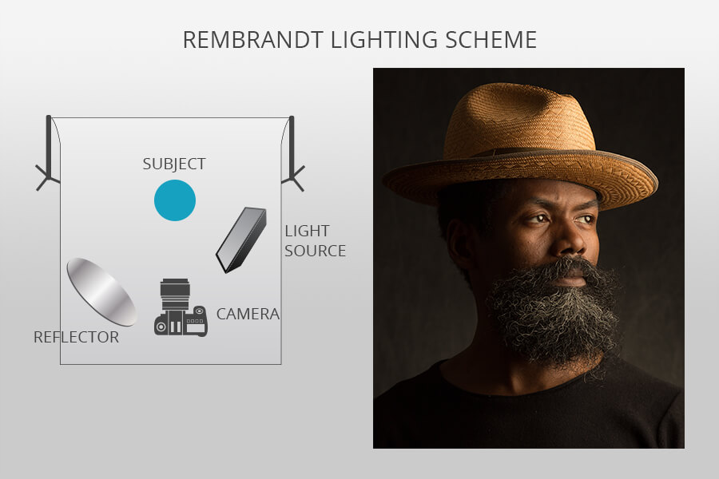

You’ve likely heard of 3-point lighting, which refers to:
- Key (primary light source)
- Fill (fills in shadows)
- Back (a.k.a. hair – helps separate subject from the background)

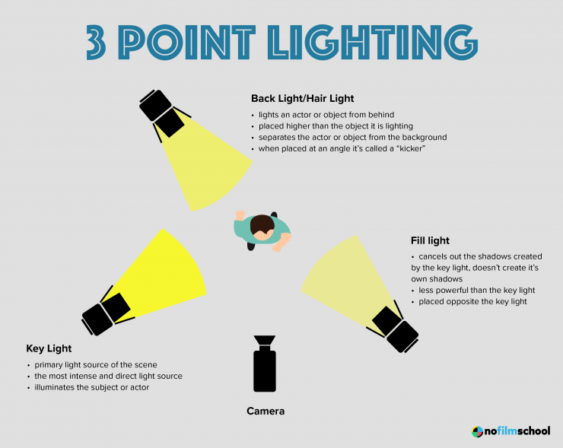

But for film and TV, we usually also have an additional set or background light, to illuminate the surroundings. This is sometimes referred to as 4-point lighting:
- Key (primary light source)
- Fill (fills in shadows)
- Back (a.k.a. hair – helps separate subject from the background)
- Set/Background (illuminates the scene or background)

Elements of Lighting

Lighting has four major characteristics including:
- Quality (Hard vs. Soft)
- Color (color temperature)
- Intensity (brightness)
- Direction (where it’s coming from)

Quality (Hard vs Soft Lighting) – If you go outside on a sunny day, you’ll see sharply defined shadows. This is known as hard light. If you’re out on an overcast day, there are no apparent shadows. This is soft light.

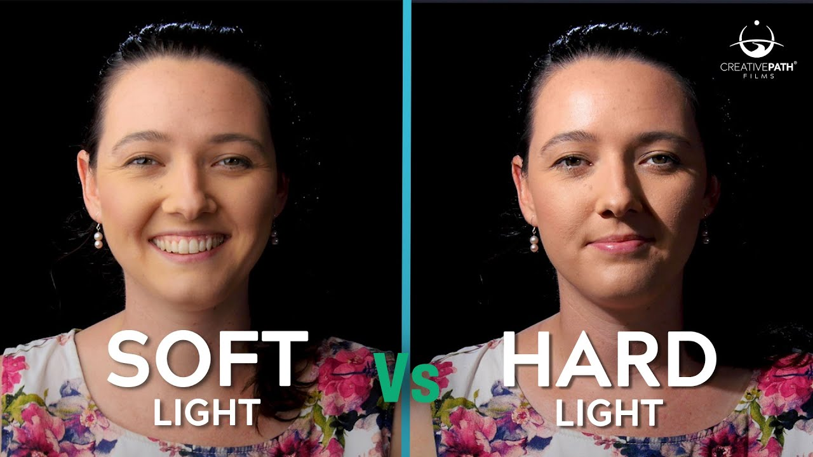

Lighting instruments can be broken down into two major types: spotlights and floodlights. In general, spotlights produce focused beams of light (hard light) and create sharply defined shadows. Floodlights create softer, more diffused light.

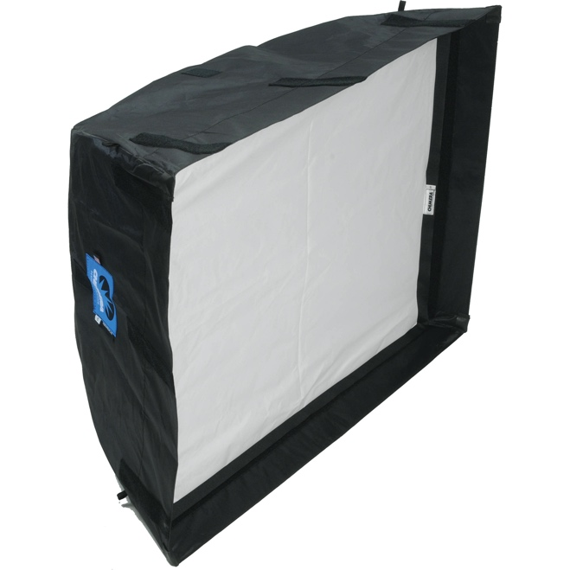 | 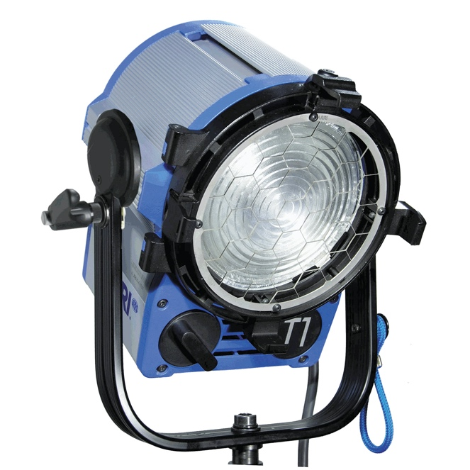
Chimera soft box | Arri Fresnel spotlight

Color

We measure color temperature using the Kelvin scale. Color temperature is determined by the type of lighting instrument. Some LED instruments have controls for varying the color. Otherwise, color can be manipulated using gels. Two important color temperatures to know are:

- 3200 Kelvin - indoor (tungsten) color temp
- 5600 Kelvin - average outdoor color temp

Outdoor color temperature varies throughout day. At sunrise and sunset (sometimes referred to as the golden hours) the color temperature is close to 3000K. At noon, with the sun directly overhead, the color temperature is closer to 6500K. But the average daylight color temp is 5600K.

We can vary color with gels, which are useful to add an artistic look or dash of color. They can also be used to correct for differences in color temperature.

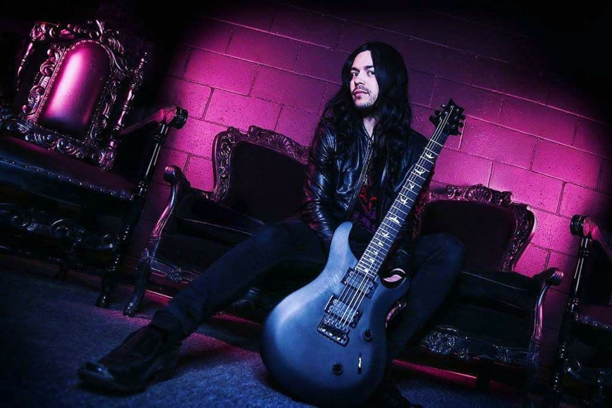 | 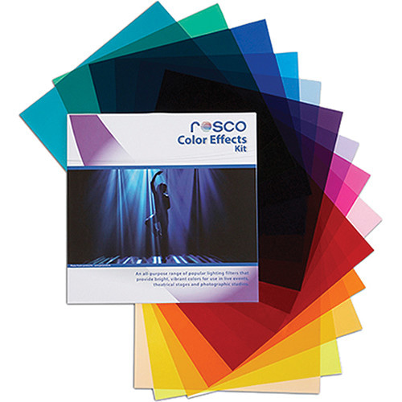
Color can make a plain background dynamic | 12” x 12” Rosco Color Gel Kit

It’s generally not good to mix indoor and outdoor color temperatures. So, two "correction" gels that help address this are CTO and CTB.

- CTO (Color Temperature Orange) This brings 5600K down to 3200K
- CTB (Color Temperature Blue) This brings 3200K up to 5600K

So, if we wanted to shoot in an office with lots of windows but at a 3200K indoor color temp, we could place CTO on the windows. Alternatively, if you were shooting outside but needed a little fill from a tungsten/halogen light- you could place CTB gel over the light.

CTO Gel | CTB Gel
Intensity

The amount of light coming out of a fixture can be expressed in lumens. Lux and footcandles are units of light intensity. (Don’t worry about these words until you take Cinematography .)

Many categorize traditional tungsten lights according to their wattage (150, 300, 650, 1,000, etc.). However, wattage doesn’t directly translate into intensity. Modern LED and fluorescent lighting fixtures are highly efficient and can output more lumens per watt than traditional tungsten lighting instruments.

We can control lighting intensity through the following ways:
- Dimmer / Lighting Console
- Scrims (wire mesh)
- Neutral Density (ND) Gels
- Placement

Dimmer / Lighting Controllers - Some lights have built-in dimmers. Most can be controlled by a lighting controller.

Scrims – Circular steel scrims can be placed in the barndoor holders of most spotlights.

ND Gels – Neutral density gels can used to reduce the intensity of a light without affecting its quality. They are often clipped onto the barndoors or inserted into a gel frame.

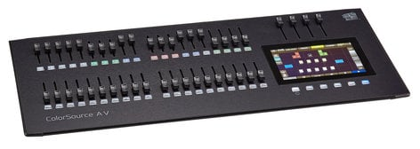 | 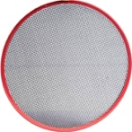
Lighting Console | Circular Scrim | ND Gel

Placement – Often the best way to control a light’s intensity if by the simplest method of placement. If more light is needed, the light is moved in closer to the subject. If less light is needed, the light can be moved farther away from the subject.

Direction – Lights must be placed in the proper location and at the proper angle to achieve the desired aesthetic effect. While there are general guidelines for portraiture and for lighting interview subjects, much is dependent on the scene, the subject, and desired artistic look. For example, if the Director requires a shadow to fall onto a wall for a certain shot, the key light and talent must be placed accordingly.

A good way to understand this is to look at two common portraiture lighting techniques.

Broad vs Narrow Lighting - To understand the importance of placement, consider two common portraiture lighting techniques: broad lighting (downstage) and narrow lighting (short or upstage). What differentiates the two is the placement of the key light.

Consider first the orientation of the subject’s gaze, which is a quarter turn away from the camera.

In broad lighting, the key light is on the camera side, so is lighting the more exposed (broader) portion of the face. In this manner, shadows fall away from the camera. In narrow lighting, the key light is placed across the subject’s orientation so that shadows fall on the camera side of a subject’s face. Narrow lighting brings out the contours or roundness of the face more than broad lighting.
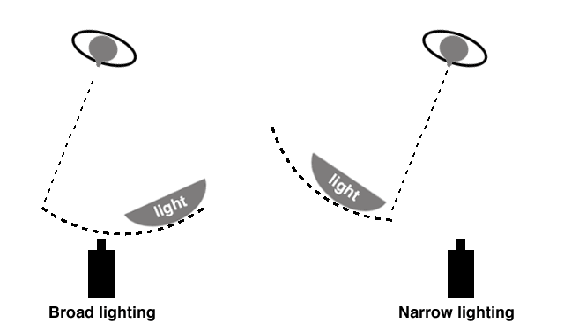
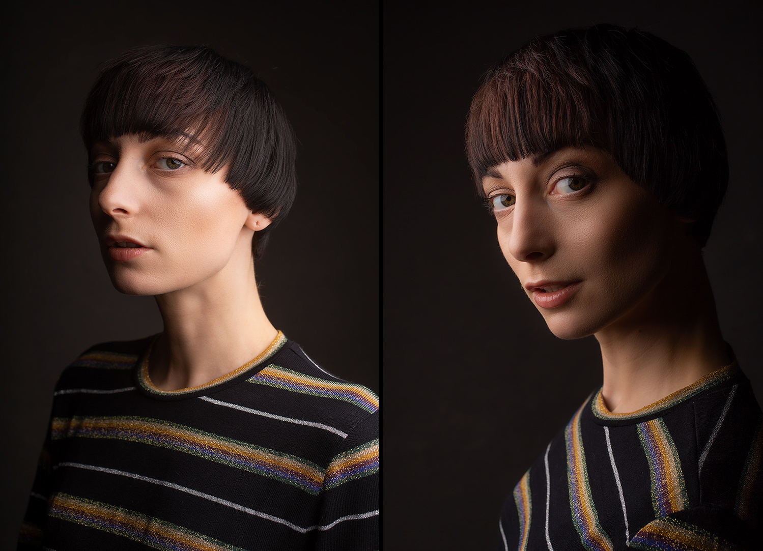

Discuss this week’s Lab Production Exercise.
Next week, we’ll continue looking at lighting techniques and explore the role of the grip department.

