Welcome to Spring 2024 229 Single Camera Production!

Agenda:
- Introductions
- Announcement from Constellation Stage & Screen
- Readings and syllabus
- Short in-class Canvas assignment
- Overview of Single Camera Production
- Gear & Using the Connect2 checkout system

Constellation Work Study Job Announcement & Readings for Week 1:

- Want a work study position? Check out the Canvas announcement with a work study gig at Constellation Stage and Screen.
- Read pages 1-23 of the IU Student Film Production Handbook (Available through the Media School checkout website: https://mschoolcheckout.indiana.edu)
- Access the Canon xf605 manual. Jim has a copy on his P351 website. (You can also find it on Canon’s website.
- Make sure you are familiar with the syllabus (You can find it on our Canvas homepage.) announcement.)
- Make sure you are familiar and can login to the Connect2 checkout system

Review syllabus, materials, etc. Be sure you have your materials by next week.

Course goals, logistics, and grading

- Goals: By the end of the semester, you should be able to work as a competent PA. You’ll know how to operate various cameras, the proper way to wind cables, how to use lighting and grip gear, understand the roles and processes required by a film shoot and have a few completed projects for your portfolio.
- Attendance at all lectures and labs is mandatory.
- Near the end of this lecture (every lecture), we’ll have a short in-class Canvas attendance assignment This is how I track lecture attendance.

A few rules (there are many more in the Student Film Production Handbook):

- If you are picking up gear, use the loading dock at the west end of the RTV building, not the fire lane.
- Absolutely no capturing footage in RTV bathrooms.
- When shooting footage in the Radio TV and Franklin Hall buildings, remember that we share it with other people, so do not block hallways or stairwells. It’s fine to shoot in them, just be considerate.

Intro to C229 Single Camera Production

TV or film production can be captured with a multiple camera or a single camera approach.

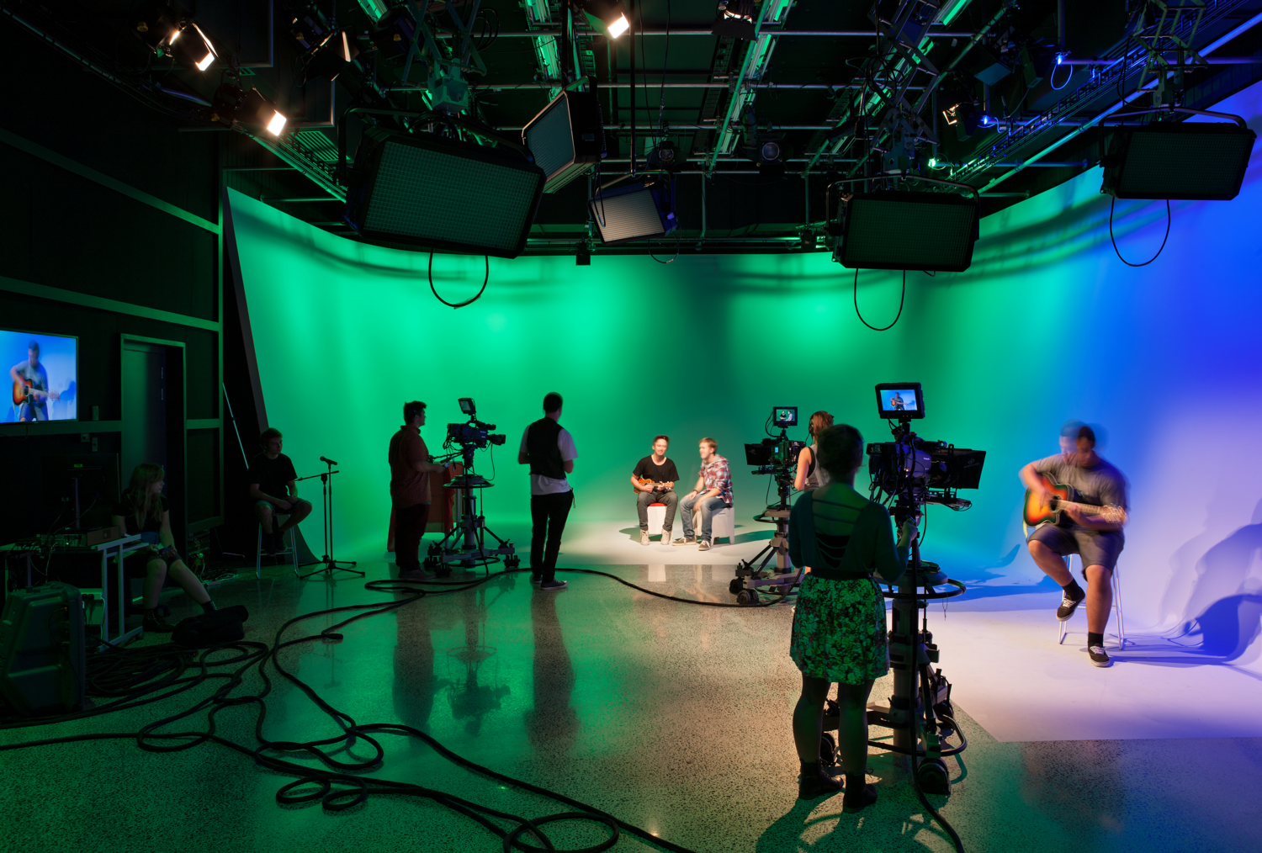

Multi-camera production: Multi-camera studios, such as Beckley (Studio 7) are ideal for producing sports, news, talk, or magazine style shows in real-time. Most of the camera selection is done live, in real-time, while the show is underway. Cameras are selected using a video switcher. (Take C228 if you are interested in this and then P356.)
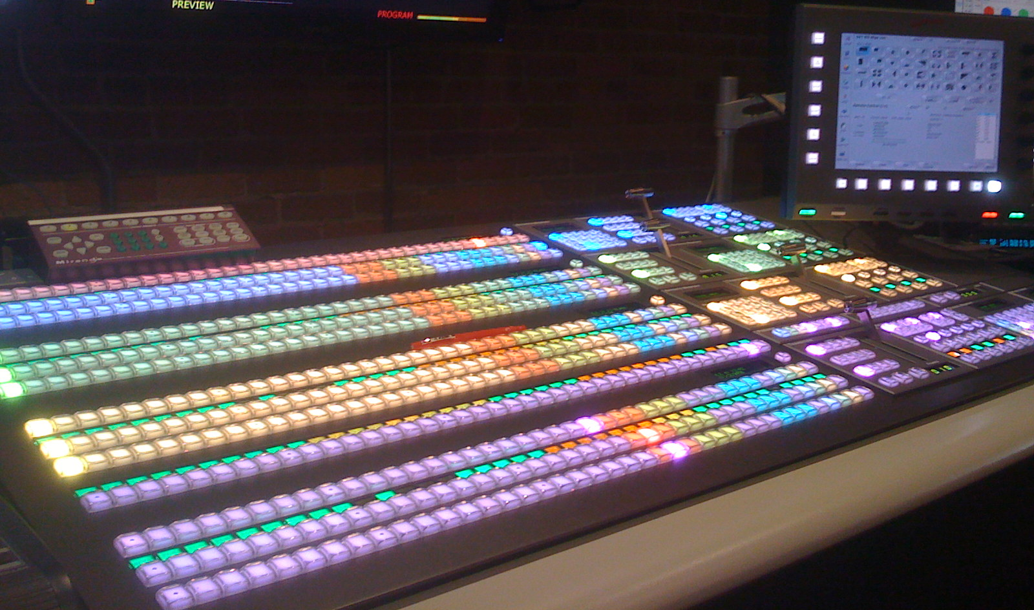

Advantages: Since most of the camera selection is done in real-time, there usually isn’t much editing required.

Disadvantages: Expensive. It requires either a multi-camera studio or bringing in a remote package. Since multiple cameras are used, they are usually placed off to the side, so that the cameras aren’t visible in the frame by the audience. This prevents Directors from placing cameras within the studio performance space and thus limits shot selection.

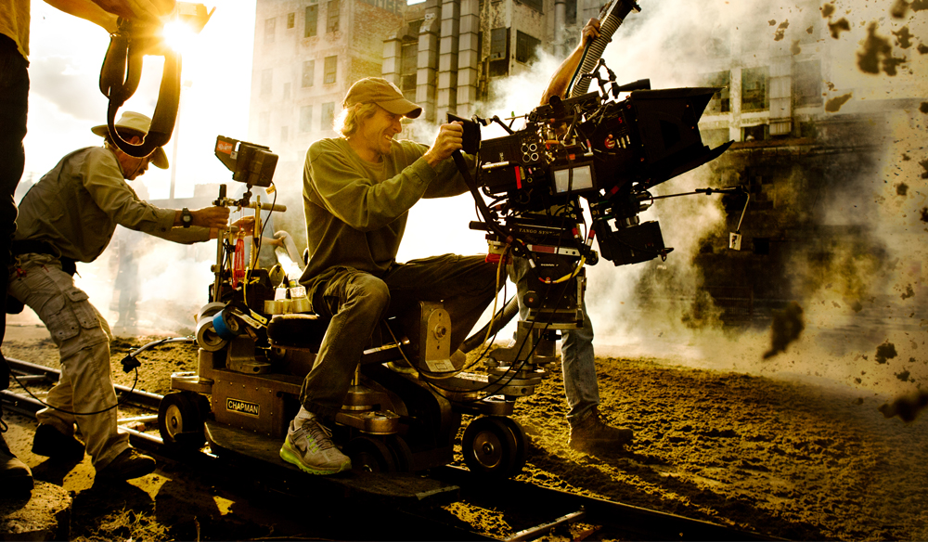

Single Camera Production: Single-camera or “film-style” production relies mainly on a single camera for coverage. After the footage is captured, it then must be edited. FYI Sometimes multiple cameras are used (Drones, GoPros, DSLRs, etc.) but the single-camera concept is still being used- footage is captured, then must be edited.

Advantages: Inexpensive, since fewer cameras are required, and it doesn’t need a multi-camera TV studio. Allows for creative camera placement. All the world is a stage (or potential set).

Disadvantages: The production process takes longer.

Single vs Dual Systems: Single Camera Production can follow a single system or a dual system workflow.

Single System refers to when the video and audio are both simultaneously being recorded into the camcorder. This is how most TV news or feature field production is done. The microphone from the talent or reporter is plugged into the camcorder and both audio and video are captured into the same media file. No synchronizing is required.

Dual System refers to when the audio and video are recorded separately onto two different devices. Audio is recorded into an audio recorder and video captured into a camera. The two must then be synchronized in editing/post-production.

The dual-system workflow is commonly used in producing movies and dramatic television. It’s also used in some commercial work, documentaries, music videos, and higher end corporate videos.

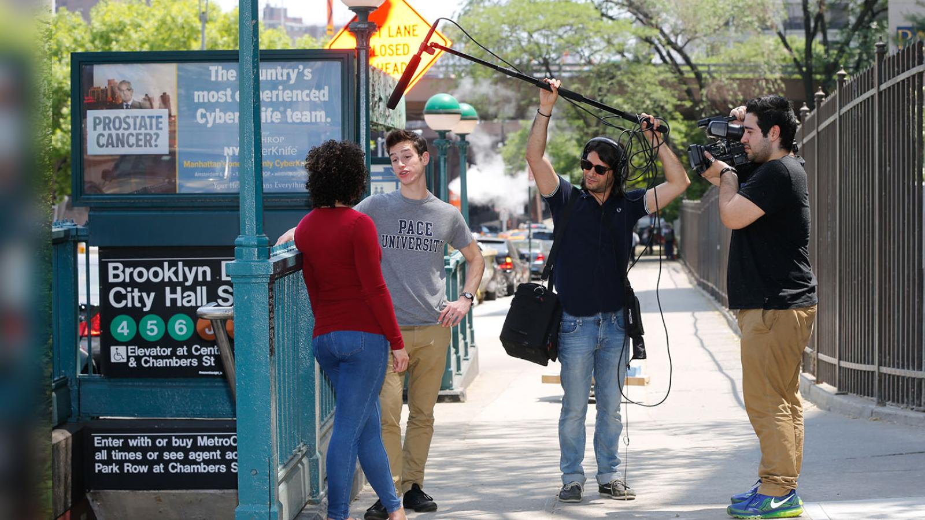
In a dual system workflow, audio and video are recorded separately, then combined in post.

There are different teams, responsible for capturing the audio and video. Before every shot is captured, it is slated, which helps synchronize the two later in editing/postproduction.

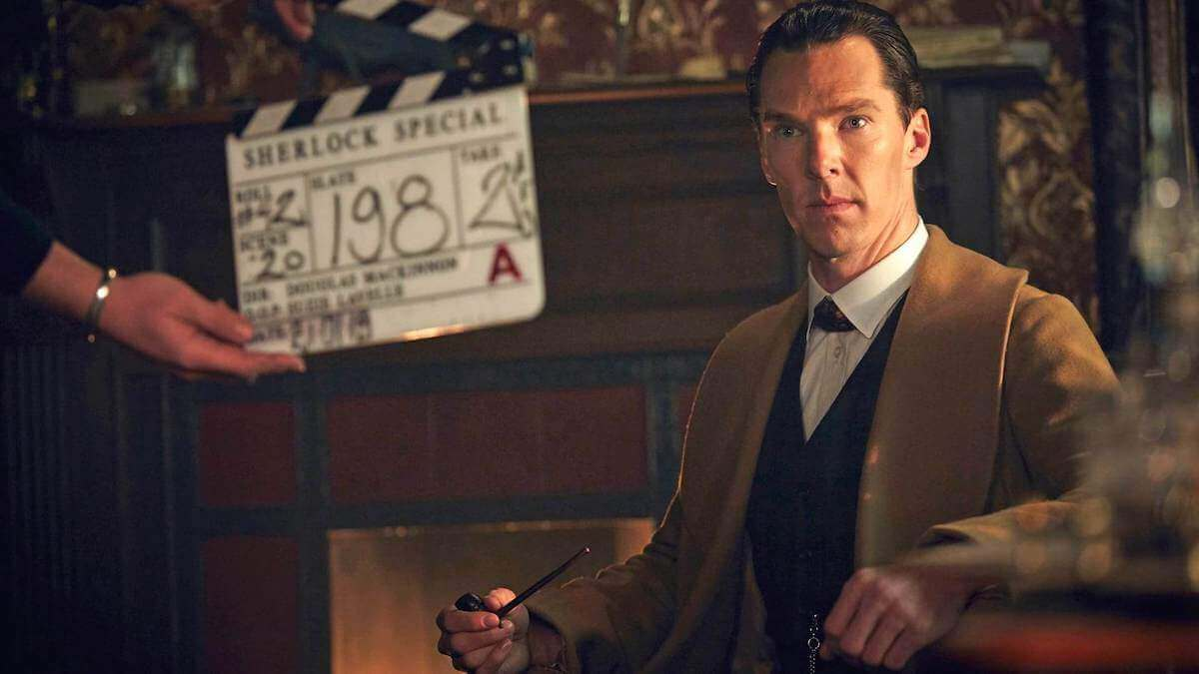
Slating at the head of a shot

Tech Talk

Frame/Picture Size: Most TV stations are broadcasting in HD (High Definition), but there are other picture sizes in use. Some include:
- Standard definition (E.g., 720 x 480)
- High definition (E.g., 1920 x 1080)
- 4K and Ultra high definition (E.g., 3840 x 2160)

We’ll be shooting and editing in 1920 x 1080 (HD) this semester.

FYI It’s possible to shoot in 4K, but the size of the data is too large and cumbersome for us to edit with.
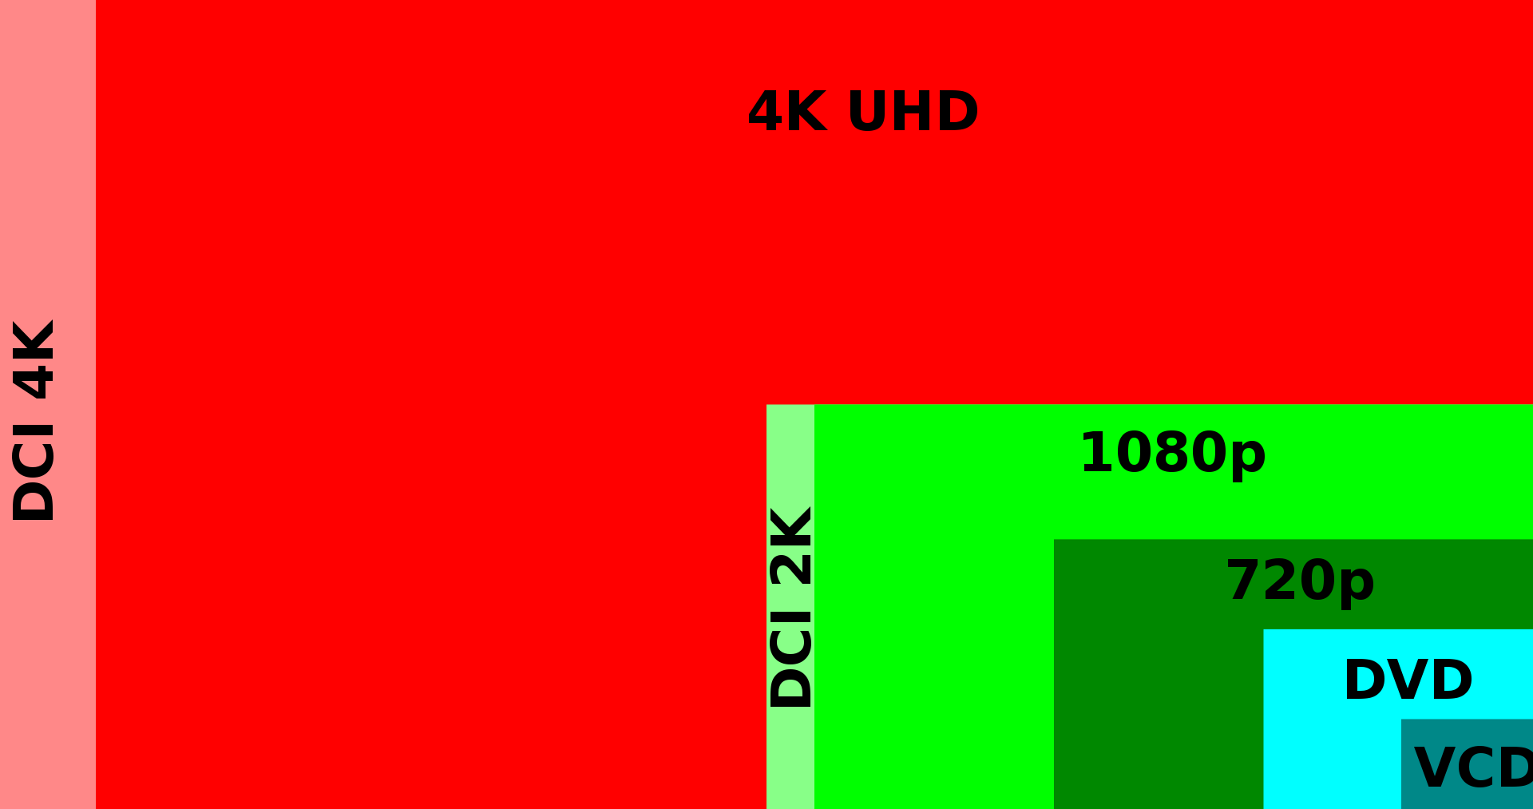
Wikipedia link to 4K article

Frame Rate: You likely know that movies are a series of still images displayed sequentially. There are two important frame rates to know:
- 24 fps (Actually 23.98 fps)
- 30 fps (Actually 29.97 fps)

Most movies are produced and shown at 24 fps.
Most broadcast TV is produced and delivered at 30 fps.

We can also use slower or faster frame rates.

To get smooth slow motion, we would capture or record a shot at a faster frame rate. If we captured a 10-seond shot at 120 fps, when played back at 30 fps, it would result in a slow motion shot lasting 40 seconds. (120/30=4)

What do you think would happen if you captured a shot at 1 frame per second and played it back at 30 fps?

Top 10 Slomo Moments: https://youtu.be/rLgmfSGQAkE
Studio Binder: https://youtu.be/7lUFluLOh-s

Formats

There are many types of formats used by cameras. The Canon xf605 cameras that we’ll be using this semester can record into two formats: XF-AVC and MP4. Within these formats, one can choose different picture sizes, frame rates, and bit rates.

Interlaced vs Progressive
Video formats can be interlaced or progressive.

Most broadcast TV is transmitted using interlacing. In interlaced formats, a single frame of video is made up of two fields, the first (A) field containing all the odd-numbered scan lines (1, 3, 5, 7, etc.) and the second (B) field containing all the even scan lines (2, 4, 6, 8, etc.). Given an interlaced format, 30 frames per second would mean there are also 60 fields per second (since each frame of interlaced video contains two fields).

Whether a format is interlaced or progressive is indicated by the small letter following the frame rate. “30i” would mean the format is 30 frames per second and composed of two interlaced fields. “30p” would indicate the same frame rate, but in a progressive format.

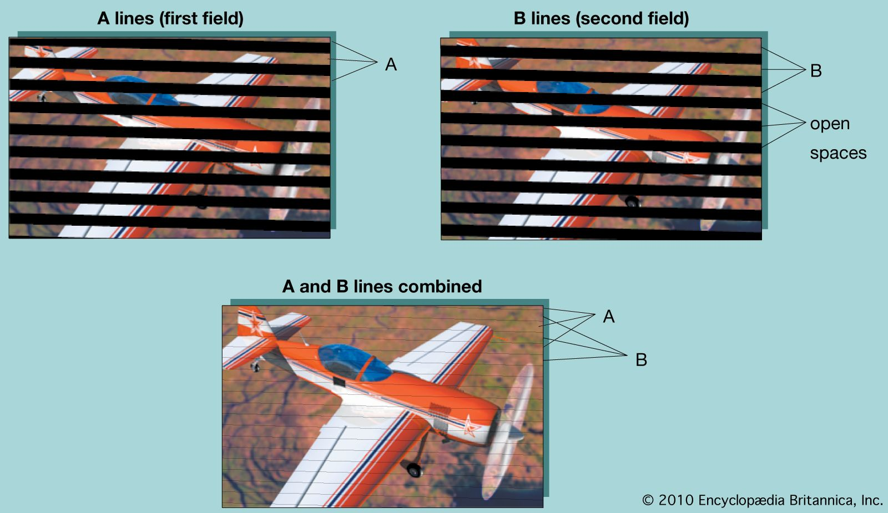

Interlaced scanning was developed to optimize broadcast transmission and is not ideal for delivering videos via the web.

Jim suggests that you use 24p for your C229 film projects (or 30p if you want to follow the frame rate of TV broadcast).

Larry Jordan: Video Interlacing and Deinterlacing

