**C229 Single Camera Production – Week 15**

**Agenda:**

* Wrap up semester &review for Final Exam
* Short in-class Canvas attendance exercise
* Please fill out the OCQ evaluations this week**. If I get 95% participation, I’ll give everyone an extra credit point!**

### The C229 FINAL EXAM is scheduled for Friday, December 20 from 3-5 pm. This time was assigned to us by the Registrar. The time is inconvenient for all yet must be adhered to. Since the exam will be given via Canvas, I see no reason to open it up a day early- and to leave it open through the end of our assigned final exam time. **I’ll open the final exam up Thursday, 12/19 at 3 pm, and leave it open 26 hours- until 5 pm, Friday, December 20. It should take you about 30 minutes.**

### **Just don’t forget to take the final!**

Please send me any good Final Projects!

**Some last advice:**

* Pay attention and be communicative. Never drop the ball. Answer emails quickly and if you don’t know the answer to something, be honest and say you don’t know.
* For people wanting to get into the film/tv business as a creative- start building your portfolio.
* A splash/demo reel is a good thing to have and doesn’t need to be longer than 3 minutes. Always have descriptions of what you did (Director, Sound Design, Editor, etc.) and never include work that you don’t legally own. (It’s good to avoid clip art, stock footage, etc.)
* It’s good to have your own website. You can build it yourself with Wordpress, WIX, SquareSpace, Adobe, etc. or have someone build it for you.
* Ideally, it’s good to have yourname.com.
* It’s also good to not just have pretty pictures and videos on a website- but also articles, reflections, etc. It’s important to convey the thinking behind the productions. This is why it’s good to post preproduction work, “making of” articles, and reflections (What have we learned?....).
* Many professionals include short articles about the projects they worked on which provide useful context.
* It’s possible to build skills on your own, but much quicker when you work with people who know more than you do.

**C229 Review**

**Review readings & watchlist that were assigned over the semester:**

* [Lens Basics (Sony)](https://www.sony.com/ug/electronics/focal-length-angle-of-view-perspective)
* [Understanding Exposure (B&H Explora)](https://www.bhphotovideo.com/explora/photography/tips-and-solutions/understanding-exposure-part-1-exposure-triangle)
* [Camera Shot Types (B&H Explora)](https://www.bhphotovideo.com/explora/video/tips-and-solutions/filmmaking-101-camera-shot-types)

**Review Topics:**

**Single camera verses multi-camera** production (advantages/disadvantages)

**Single system vs Dual system** production

* Workflow differences (audio, slating, editing, etc.)

**Frame Rates/Picture Size:** Most TV stations are broadcasting in HD (High Definition), but there are other picture sizes in use. Some include:

* Standard definition (E.g., 720 x 480)
* High definition (E.g., 1920 x 1080)
* 4K and UHD (Ultra High Definition E.g., 3840 x 2160)

**Frame Rate:** There are two important frame rates to know:

* 24 fps (Actually 23.98 fps)
* 30 fps (Actually 29.97 fps)

**Interlaced vs Progressive** (60i vs 24p or 30p)

Aperture / f-stop/ iris / Depth of Field

**What impacts Depth of Field** (Aperture!)

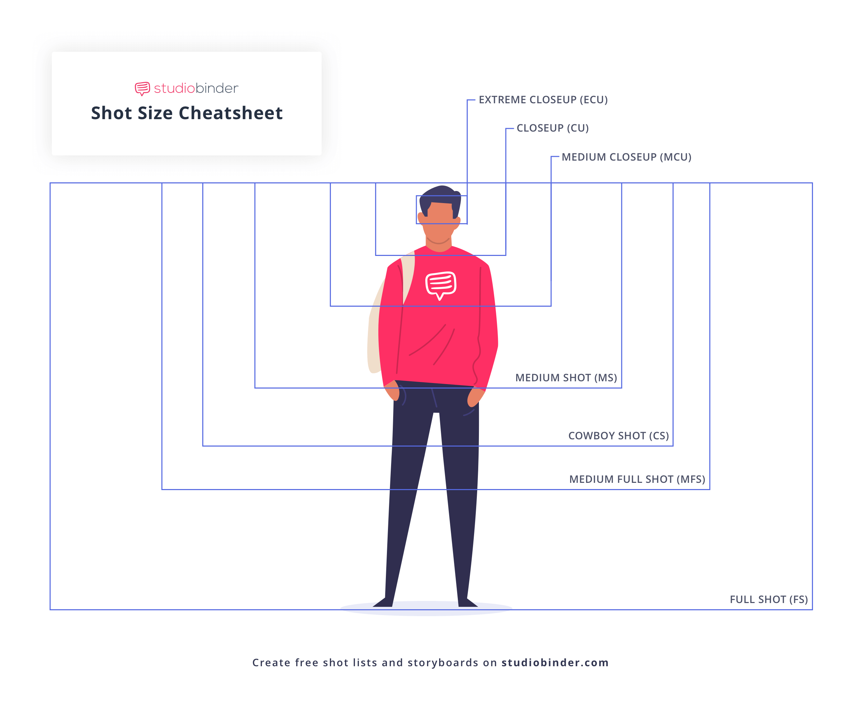

**Camera Gain/ISO**

**Setting Proper Exposure** (Tools include Zebra stripes, Waveform Monitor, etc.)

**Exposure Triangle** (Aperture, ISO/Gain, & Shutter speed)

**How to Set Focus** (Tools include: Peaking, Magnify, etc.)

**How to Set / When to White Balance**

**Focal length & Angle of View** (Telephoto vs Wide Angle)

**Prime lenses vs Zoom lens**

**Shot Types:**



**Camera settings checklist:**

* Initialize SD card before you start filming
* Set your frame rate (either 23.98 for film or 29.97 for TV)
* Set your shutter speed (always double your frame rate 1/48 for film or 1/60 for TV)
* Set your CODEC (mp4, XF-AFC, etc.)
* Set your resolution and bit rate (1920x1080 35mbps or 17mbps)
* White Balance (check/set for proper color temp)
* Check ND filters & Gain/ISO
* Turn on any focus and exposure assists you want to use such as Peaking or Zebra Stripes

**Premiere Post Shoot Workflow** – After finishing a shoot:

* Copy entire contents of SD/CF card (root/top level) to an appropriately named folder on your dedicated media drive (E.g., “Week 2 Field shoot August 22”).
* Eject the SD/CF card.
* Launch Premiere and save the project to your media drive (E.g., “C229 Project 1”).
  + TIP: It’s good to make sure your Scratch Disks are set to “Same as Project”. You can find this under File/Project Settings.
* Use the Media Browser to link to the footage.
* Import media and edit
  + TIP: Backup your entire media drive to multiple locations (E.g., another SSD).

**Lighting**

* What is the Lighting Triangle made up of?
* What is the additional, 4th light, we typically add?
* Soft verses Hard lighting
* What are the standard color temperatures for inside and outside?
* Broad verses Narrow lighting

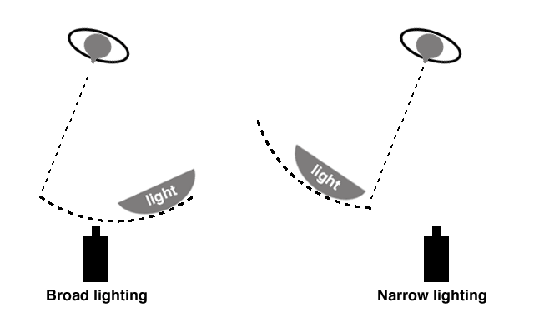

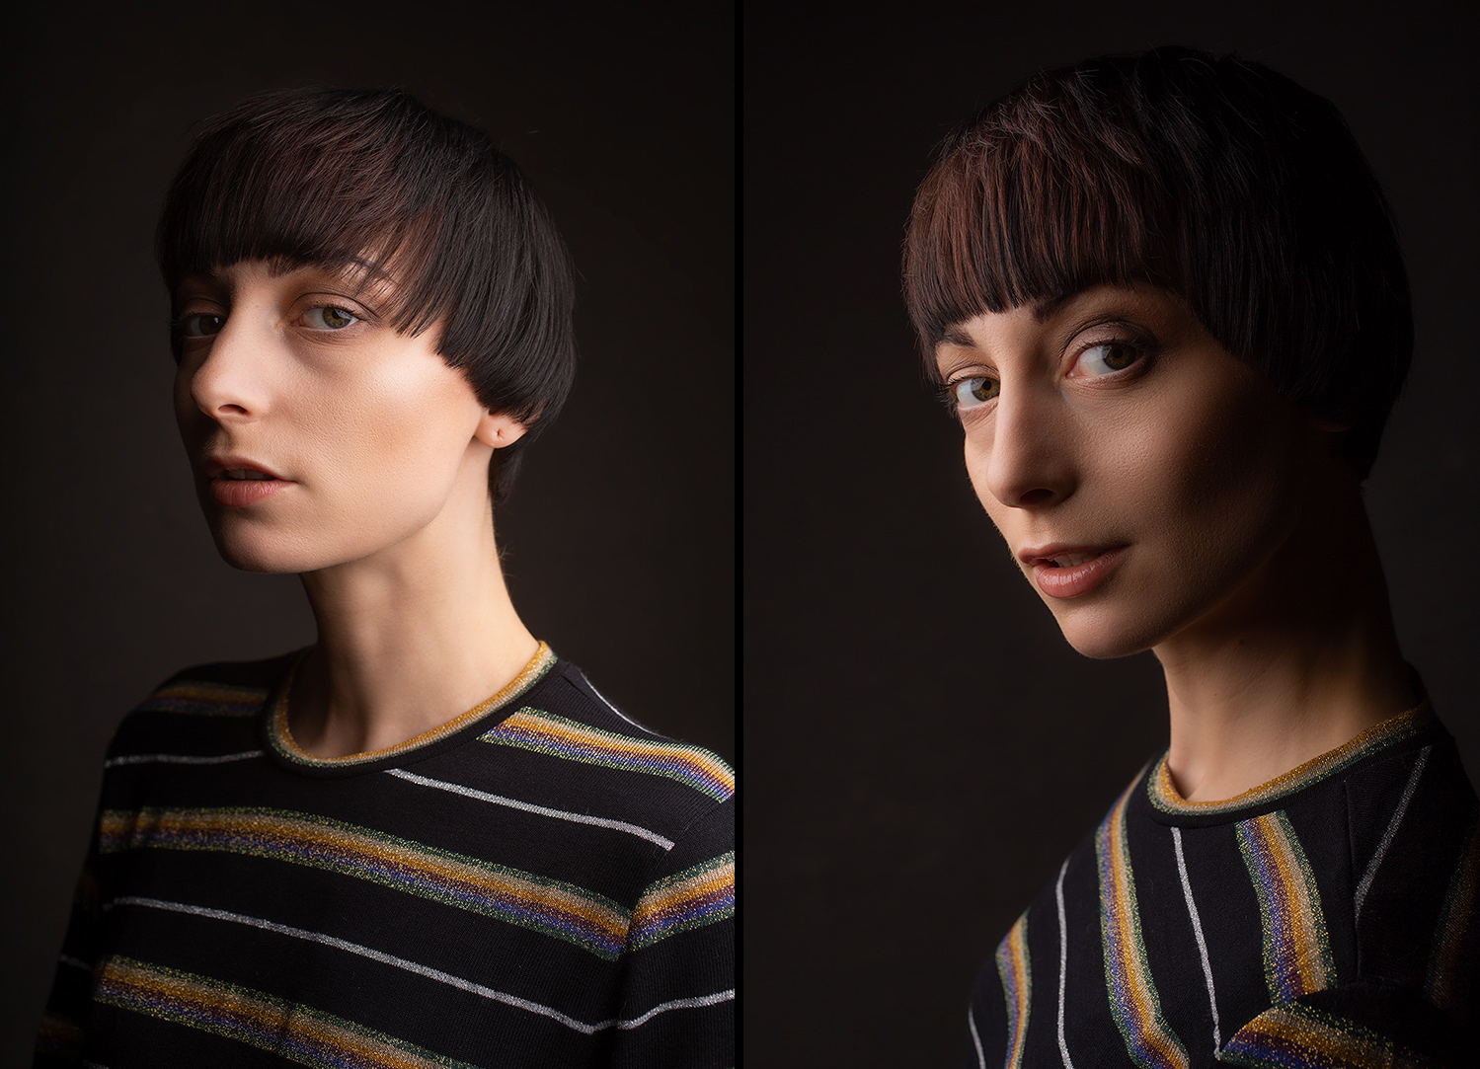

Know different types of lights (Spotlights, softboxes, LED, etc.)

**Grips & Gaffers** (What’s the difference? Which one works with electricity?)

* How to use C-Stands
* How to carry C-stands
* **What to call out when you’re moving gear**

Editing – Premiere Basics – NOT going to be on the final!

**Directing/Producing**

* [Continuity Editing in Film (Studio Binder)](https://www.studiobinder.com/blog/what-is-continuity-editing-in-film/)
  + [The 180-degree Rule](https://youtu.be/iW0bKUfvH2c)
  + [What’s the 30-degree rule?](https://youtu.be/1K8EUc98VoQ)
  + [Match Cuts](https://youtu.be/ptXlYulVAsM)
  + [Eye Trace](https://youtu.be/xUK64UkTmW0)

**Sound**

* Range of Human Hearing (20 Hz to 20 kHz)
* Phantom Power
* Types of microphones
* Microphone Polar patterns
* Microphone electrical characteristics (Dynamic, Condenser, etc.)