C229 Single Camera Production – Week 12

Agenda/Announcements:
- This week in lab, you’ll watch the 1st narrative projects and practice capturing audio with the Sound Devices MixPre.
- Send me any good narrative projects! Thanks to those who already sent me some. :-)
- Next week – No class due to solar eclipse. There still are lecture notes (focusing on documentary) and an easy Lecture Canvas assignment. You’ll have all week to do it.
- Call Sheets and Slating
- Getting proper exposure and focus with the C100
- Storytelling Tips
- Short in-class Canvas attendance exercise
Readings/Watchlist:
- Intro to Audio (Media School Tech Tutorial article)
- Sound Device MixPre (Media School Tech Tutorial)
- What is a Call Sheet? (StudioBinder) – NOTE Who sends it and what’s on it.
- What is a Call Sheet? (MasterClass)
- Film Set Etiquette (Studio Binder)

Reality Check – C229 focuses on workflow required for single camera production. Please know that the skills, tools, and techniques covered in class apply to much more outside of narrative production. This includes:
- Documentary
- TV shows (Magazine, biopic, reality, etc.)
- Advertising
- Social media
- Art & Music videos

MixPre – Important Points:
- The MixPre takes Sony batteries (check out extra batteries)
- Format SD card before use
- Be sure you’re set for 48 kHz, 24-bit recording (For an explanation of Bit depth and sample rate, check out the info from PreSonus.)
Film Set Protocols & Etiquette
There are many things to learn about working as a crew member or talent on a film set. We’ve already covered the grip department. (How to carry gear, call out warnings, and set up C-stands and other grip equipment.) There’s a good rundown on set etiquette at StudioBinder. Let’s add a few more elements: Call Sheets and review Slating. But here are a few bonus rules:
- Rule #1: Keep quiet / don’t talk
- Rule #2: Stay in your own department

Call Sheet – A Call Sheet is sent to cast and crew members by the 1st Assistant Director the day before a shoot. It outlines the film/production schedule for a given day and important information all should know. This includes location, cast and crew (arrival) times, parking, restroom location(s), the production schedule, safety information, important contact numbers, and even the weather.
- What is a Call Sheet? (StudioBinder)
- What is a Call Sheet? (MasterClass)

Clapperboard / Slate
Be sure to review the protocols for using slates and marking them.
https://www.studiobinder.com/blog/how-to-use-a-film-slate/
Getting Proper Exposure and Focus with the C100

Getting Proper Exposure - The C100 cameras have two features to help get proper exposure, a waveform monitor and zebra stripes. Consider these exposure-assist tools. Switching either of these features on makes them visible in your viewfinder display but NOT in the recorded video.

Waveform Monitor – This feature can be turned on to appear in the viewfinder of most professional cameras. (On the C100, press the WFM button on the rear of the camera.) Waveform monitors display the luminance or brightness levels of the video signal. The darkest blacks should register at 0 IRE. The brightest elements shouldn't be over 100 IRE. For example, if you were capturing an exterior wide shot of brightly lit clouds on a sunny day, the clouds should be at 100 IRE. The camera operator can turn on the waveform monitor and adjust the iris, ND filters, and gain/ISO (which should be 0 dB) to get proper exposure, which would be the clouds at 100 IRE.

 | 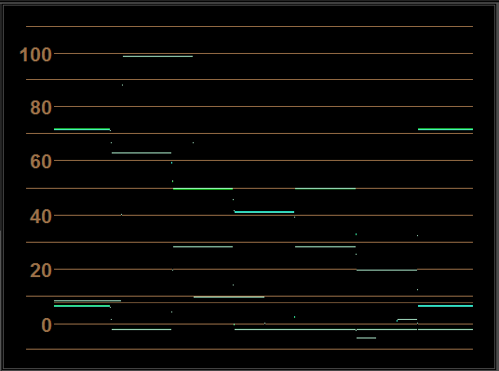
SMPTE color bars | Color bars displayed on a waveform monitor

Zebra Stripes – This feature creates noticeable diagonal stripes that appear in the viewfinder when a certain preset luminance or brightness level is reached. (On the C100, press the ZEBRA button on the left side of the camera.) Like the waveform monitor, this exposure-assist feature appears in the viewfinder and NOT in the recorded video. Using the menu settings, set the zebra stripes for the IRE level you’d like them to appear (70, 95, 100, etc.).

Note: The C100 cameras have two sets of zebra stripes that can be set individually. One set goes top left to bottom right, the other from bottom left to top right. You can view them separately (Zebra 1 or Zebra 2) or both at once. You can access this via the Menu.

For the same example from before (exterior wide shot of brightly lit clouds on a sunny day), let’s say the camera operator set the zebra stripes for 95 IRE and is starting with an underexposed image. He/she could open the iris until the zebra stripes became visible on the clouds.

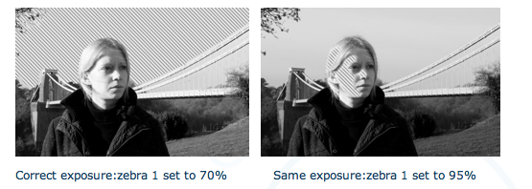

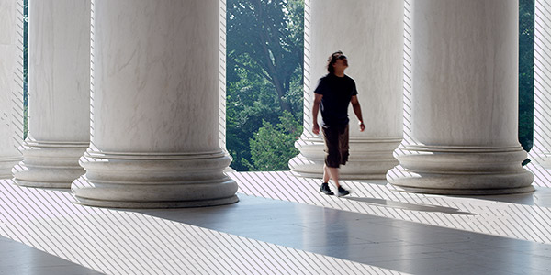
Zebra stripes can be used to let you know when you’ve reached a preset exposure (IRE) level
Setting Proper Focus

Most cameras have displays and viewfinders that are too small to set critical focus by. Fortunately, most professional cameras have two features to assist with this: Peaking and Magnify. Like the exposure-assist tools (waveform monitor and zebra stripes) these focus-assist tools only appear in the viewfinder, and are not recorded to video.

Note: Before you try to use these features, make sure you are in Manual Focus mode (not auto focus) or you will not have much luck. :-)

Peaking – This feature creates outlines around the elements that are sharply in focus. The button is on the left side of the C100. For the C100, Peaking can be set to White, Red, Yellow, or Blue. I like keeping mine set for Red, since it’s easily noticeable.

Magnify – This feature simply enlarges the screen, it’s like holding a magnifying glass up over the viewfinder. There are two Magnify buttons on the C100: One is one the left side of the camera, another is on the handle, facing back towards the operator. Once you have Magnify turned on, you can use either of the joysticks to move the expanded area around. Don’t forget to turn it off! (I’ve left mine on more than once!)

Skills – It’s good to be able to do and use the following:

- Detach / attach lens hood (align red dot)
- Turn on/off
- Format card
- Set recording format & frame rate (codec, bit depth, etc.)
- ND filters – How to turn off/on
- Diopter adjustment for eyepiece
- Display (turning off/on)
- Magnify feature (how to use, move around, and turn off/on)
- Peaking (how to use, turn off/on)
- Waveform Monitor (how to use, turn off/on)
- Change lenses (don’t do without instruction and a clean environment)

Storytelling Tips – Keep it simple (the fewer actors and dialog, the better)

Vocabulary:
- Call Sheet
- Closeup (CU)
- Coverage
- Establishing Shot
- Magnify
- Master Shot
- Medium Shots (MS)
- Over the Shoulder Shots (OTS)
- Peaking
- Reverse Shot
- Slate (protocols for using and marking)
- Waveform Monitor
- Zebra stripes

