C229 Lecture Week 10

Agenda:
- Intro to Audio
- Audio Techniques & Examples

Readings/Watchlist:
- Sound Device MixPre (Media School Tech Tutorial)
- How to Sync Audio and Video in Premiere Pro CC
- Dynamic vs Condenser Mics (Sound Engineering Workshop)
- Operating a Boom Mic (Film Craft 107: The Location Sound Mixer)
- Audio Sample Rate and Bit Depth (from Izotope)
- How to Wrap a Cable Over Under & How to Wrap Audio Cables & How to Wrap Cables and Cords

Intro to Audio in TV and film - Audio for film and TV involves both field production and editing/postproduction (two related but different disciplines).

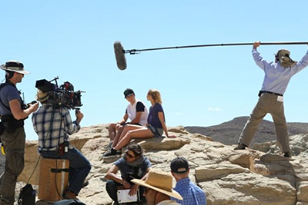 | 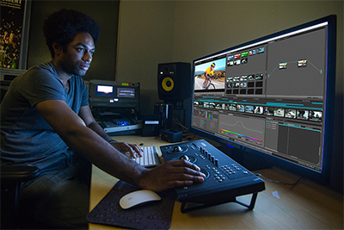
Field Production | Editing/Postproduction

Most soundtracks have multiple layers of sound: dialog, environmental ambience, sound effects, and music. We hear audible cues telling us where we are- outside, inside, and how big the room or environment is. From the soundtrack, we can tell how many people are in the background, what they are doing, and even what the weather is like.

Elements of a TV or movie soundtrack:
- Natural (diegetic) audio
- Dialog
- Environmental sounds
- Sound effects
- Music

When done right the audience doesn't notice the soundtrack - but it's adding important information and meaning to the scene.

Audio Perspective – Our ears are amazing- telling us if sounds are coming from far away, close by, or in front, over or behind. In TV and film, the audio perspective usually matches the visual perspective. Characters at a distance sound farther away than subjects closer to the camera.

Consider these two shots:

- Wide Shot inside a busy diner full of people.
Our two lead characters enter and move towards a booth.
- 2-Shot of our characters in the booth.
They start to talk.

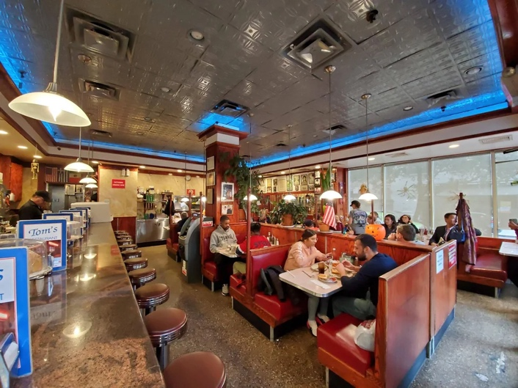 | 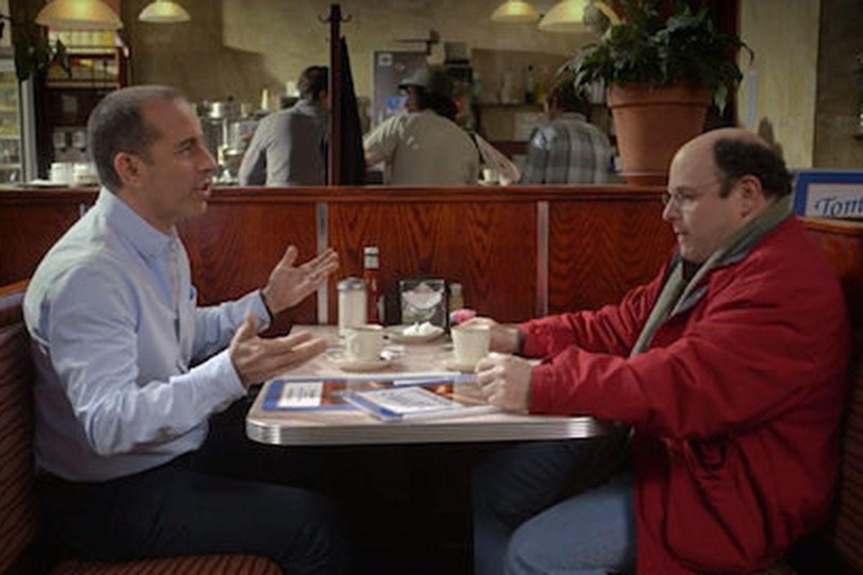
Wide Shot | 2-Shot

In the first wide shot we'd expect to hear diner noise and lots of ambient sounds. In the 2-shot we'd expect to hear their conversation and less ambient diner sounds.

This is why in film and TV production; the shotgun microphone is usually favored over lavalieres. We can vary the distance (matching the camera) so the audio perspective matches what we are seeing through the lens. Lavaliere microphones are always close to the subject and must be concealed for narrative work.

Loudness, Gain and Frequency

Loudness or sound intensity can be measured in decibels (dBs) and can be represented visually with VU (volume unit) or digital level meters.

Gain – Gain refers to the amount of amplification applied to the signal. It’s also expressed in dBs. Gain is the difference in signal strength between the input and the output.

AGC - The automatic gain control feature on a camcorder tries to get a consistent level. If it’s soft, it’ll boost the signal. If it’s loud it’ll turn it down. Don’t use it! It’ll bring the noise floor up and reduce your dynamic range.

Frequency – Frequency (aka pitch) is the number of wave cycles occurring in a given unit of time (E.g., one second). Frequency is described in units of Hertz (Hz) or cycles per second (CPS), which mean the same thing.
Hertz = CPS cycles per second (100 Hz = 100 CPS)
Kilohertz (kHz) = 1000 Hertz (1000 Hz = 1 kHz)

Human hearing generally ranges from 20 Hz to 20 kHz. It’s useful to know frequency ranges of common sounds.
- Bass 20-250 Hz
- Concert A = 440 Hz
- Middle C is 261.63 Hz
- The human voice ranges from about 100 – 250 Hz- but with overtones and sibilance up to 9,000 Hz
- Low cut filters (high pass filters) on microphones reduce sounds lower than 80-100 Hz.

Microphones

Microphones convert acoustic sound waves into electrical current. Microphones can be classified in several ways: by their electrical characteristics, their polar pickup patterns, and their design or application.

Electrical Characteristics:
- Dynamic - Works opposite of a speaker. A wire coil attached to a diaphragm is suspended inside a magnetic field. Sound waves hit the diaphragm making the coil move. This creates a flow of electricity in the coil windings.
  - Dynamic microphones are usually durable and a good choice for handheld vocals or recording percussion.
- Condenser - (a.k.a. electret or capacitor) Condenser mics need batteries or phantom power to operate. The Media School has shotgun microphones (which operate on phantom power or batteries) and Sony ECM-44B lavaliere microphones (which only work with AA batteries).
  - Condenser microphones are generally more sensitive than dynamic microphones. They are a better choice for distant recording and lower-level sound sources. Most full range, high-quality studio microphones are condensers.
  - Phantom power is DC voltage sent through the microphone cable to power certain types of condenser microphones. (48, 24 or 12 volts) It originates from a camera, audio recorder, audio mixer, or other audio device.
- Ribbon – A thin (delicate) conductive piece of metal is suspended within a magnetic field. They are fragile so aren’t usually found on film/TV shoots.

Polar Pickup patterns (4 commonly used in film production):
- Cardioid (a.k.a. unidirectional) They have a directional (heart-shaped) pickup pattern
- Figure eight (a.k.a. bi-directional)
- Omnidirectional - pickup sounds well from all directions.
- Shotgun - very directional. Frequently used on boom poles.
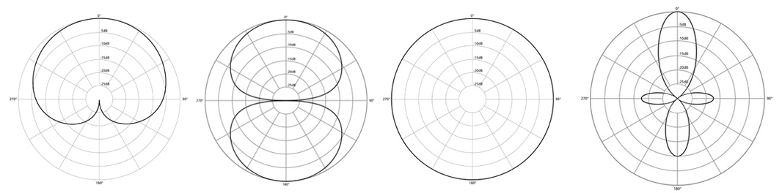
Cardioid Figure-8 Omnidirectional Shotgun

Design / Applications:
- Lavaliere – Small, easy to conceal microphones widely used in film and TV production. Wireless versions are useful, but should only be used when absolutely necessary, as they are more prone to problems than wired versions.
- Handheld – Can be handheld or mounted on a stand.
- Headset – Provide audio monitoring for performers and a consistent sound source. (Used frequently for sporting events and by performers.)
- Parabolic – Used for capturing sounds at a distance (not typically used in film production).

Mounting:
- Mic Stands (floor & desk) - Mic stands are obtrusive but allow for positioning close to the source.
- Boom pole / Fishpole – Boom poles (aka fishpoles) are typically used with a shotgun microphone but can also secure other microphones (E.g., stereo pair). It’s common to see audio operators holding a fishpole on set, but they can also be gripped to a stand.
- Shock mount – Shock mounts isolate the microphone from the stand reducing noise caused by physical transmission.

Signals, Cables, and Connectors:

Mic / Line Level – The XLR audio inputs on camcorders and audio mixers can usually be switched from line level or mic level. Electrically, these are very different. Be sure the input is set to match the signal going into it, Otherwise, you won’t be able to get proper audio levels or can create distortion.

Cables – Microphone cables are balanced (have three wires: +, - and ground) which helps minimize electrical noise and allows for longer cable runs. Speaker wires usually have two wires (+ & -).

- Know how to properly wrap cables! Ask in lab if you need a refresher. See:
  - How to Wrap a Cable Over Under
  - How to Wrap Audio Cables
  - How to Wrap Cables and Cords

Common Connectors:

- XLR
- Quarter phone – They come in both mono (E.g., like an electric guitar cord) or stereo (for headphones). Notice the difference in construction of the connectors. An electric guitar cable has 2 wires (a tip and sleeve), while a headphone jack has 3 wires (a tip, ring, and sleeve).
- Mini-phone – This is the same as a quarter phone plug but smaller. You’ve most likely seen these used for headphones.

Audio Monitoring - The audio playback most use for home theatre or stereo systems is far better than what you have access to in the Production Lab. Don't trust computer speakers or an inexpensive pair of headphones. If you want to create good soundtracks invest in either a good pair of monitors or headphones. (Headphones are good investment for production students since they are relatively inexpensive, and you can bring them with you on set and use them for editing.)

Sound Devices MixPre (Media School Tech Tutorial)

The Sound Devices MixPre can record multi-channel digital audio. This is extremely useful for Dual System productions. Be sure you know how to format media, setup the Sample Rate and Bit Depth, and turn on the Phantom Power for use with Condenser microphones. Use 48 kHz sample rate at 24 bits for film/TV audio.

Audio Terms:
- ADR (Automated Dialog Replacement) - The process of replacing dialog and sounds in post-production.
- Compressors - Used to reduce the dynamic range (loudness) creating a more consistent level. This is useful for dialog and narration. Compressing the dialog can make it easier to mix it in with music and other audio elements.
- Foley - Named after Jack Foley, the term is used to define the process used to re-create sound effects during the post-production phase.
- Pop-filter - Stops the letters B, P and T from "popping". Pop-filters are usually a thin piece of fabric. A windscreen can serve as a good substitute in the field
- Proximity Effect - Sounds closer to the microphone have an exaggerated low frequency response. (Part of the reason radio announcers sound so "bass-heavy" is because they are talking right into the mic.)
- Reverb – The echoes of sounds reflecting off surfaces (walls, floors, ceilings, canyon walls, etc.).
- Shock mount – Typically made with elastic suspension to prevent the microphone from picking up extraneous sounds from vibration and physical transmission.

Jim's Audio Production Tips:
- Before production devise a strategy for recording audio
- Plan time in your postproduction schedule for sound design.
- Editing - Focus on first making a "radio edit", which is focused on the soundtrack (dialog, music, SFX, etc.). This creates a foundation that you can edit to. Audio is important for motivating edits.
- Keep it legal! - Make sure your soundtrack has legal integrity. Using unlicensed music will prevent you from entering festivals, being shown on TV, and getting screened in festivals. If you need background or thematic music, use your Universal Production Music account.

Recording:
- Lavaliere and shotgun/hyper-cardioid are your "go-to" microphones in video/film production. Get your microphones close to or on your subjects.
- Use wireless microphones only with good reason.
- Monitor your recording with good headphones (enclosed are useful for loud environments). Make sure your levels are in the proper range. Listen for popped Ps or Ts, and any other distortion.
- Don't use AGC (automatic gain control), as it diminishes the dynamic range.
- When shooting any video or film, always record audio- even if you don't think you need it.
- DSLR/film shooters: When recording non-synched sound with a separate audio recorder always slate or clap to establish a sync reference.
- On location, always record 30-60 seconds of ambient audio with the same microphone(s) you are recording with. (Called room tone.) This can be layered into the soundtrack during post. If you need to add dialog or sounds to a scene, you’ll have the room tone to lay under it.
- When scouting shooting locations listen. Is it quiet? (Vehicle noise, construction, etc.)
- Are you recording a person on set, in the field and also recording voice overs? If so, use the same microphone.

Attendance question: What is the polar pickup pattern of the microphone being shown?

